// Number of axis tick labels to draw so that they are not drawn on top of one another.
numXTickLabels: 10,
numYTickLabels: 8,

In easy term, this is to make 10 column and 8 rows

// Determine how many x-axis labels to skip.
var xLabelSkip = ceil(numYears / this.layout.numXTickLabels);

to get a number which will be a divisible to determine how many years will be jump, so that the graph will be visually pleasing

if (j % xLabelSkip == 0) {
drawXAxisTickLabel(previous.year, this.layout, mapYearToWidth.bind(this));
}

Used bind so that “this” will refer to NutrientsTimeSeries and not get conflicts with other functions
Reference: pay-gap-1997-2017.js code + https://www.w3schools.com/js/js_function_bind.asp + https://www.geeksforgeeks.org/javascript-function-binding/

Reference for my extension: https://www.youtube.com/watch?v=gmLzi1w85t4 + https://www.chartjs.org/docs/latest/charts/radar.html
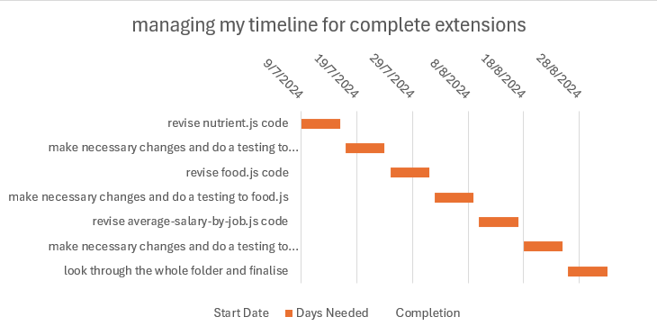

https://www.youtube.com/watch?v=ZHmwE8jMtMw
https://www.chartjs.org/docs/latest/charts/radar.html

